1. Display your name as plane text WEB Browser.

Code:

.. 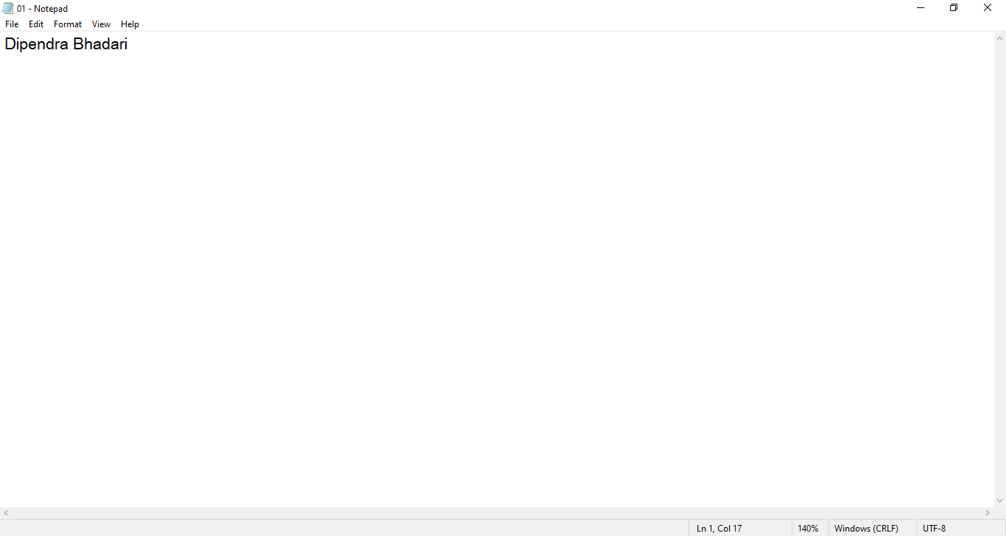

Output:

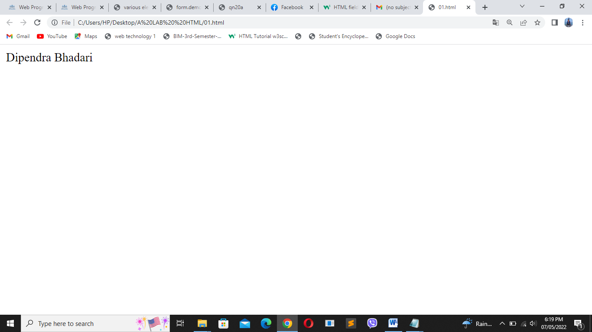

1. Display your name in WEB Browser declared inside the body.

Code:

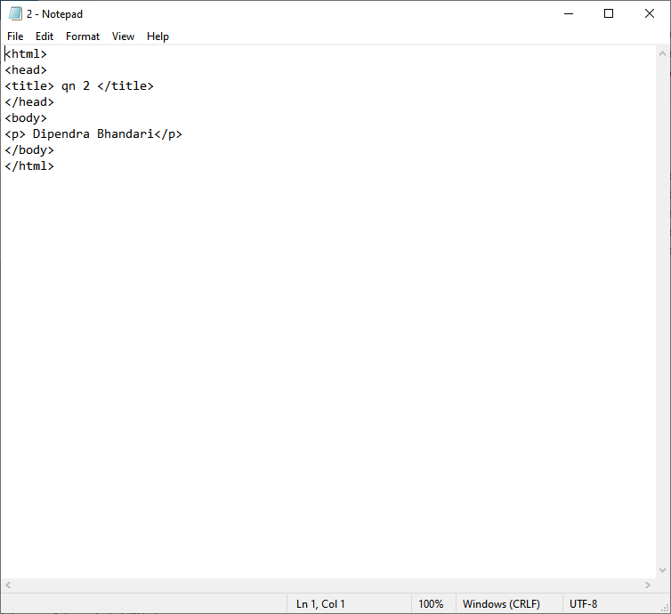

Output:

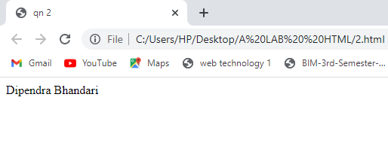

1. Write a complete source code to demonstrate the use of html, head, title, body tag.

Code:

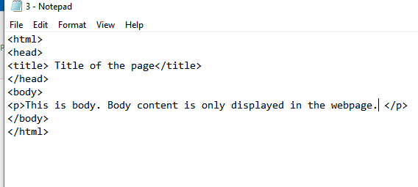

Output:

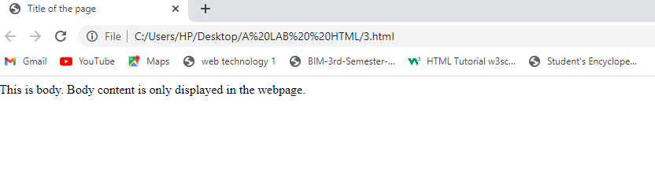

1. Write a source code to demonstrate whitespace collapsing .

Code:

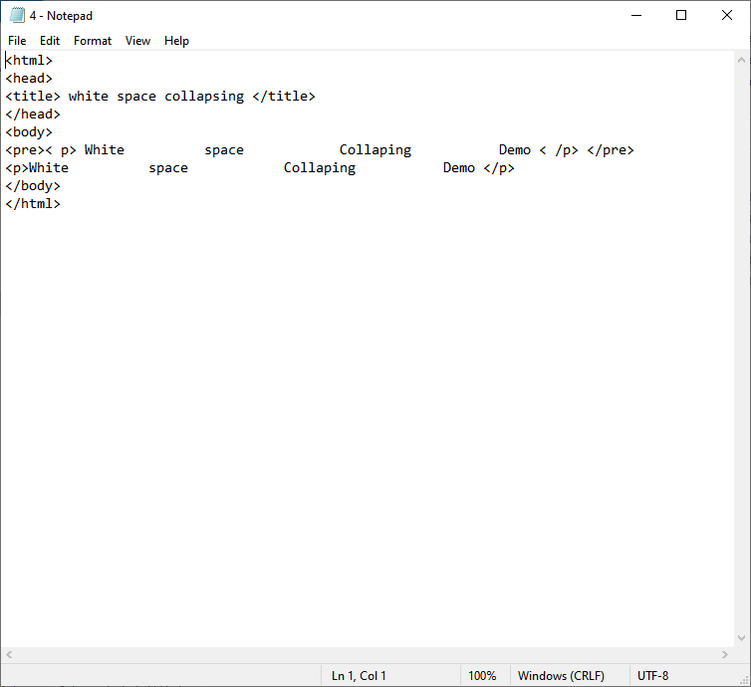

Output:

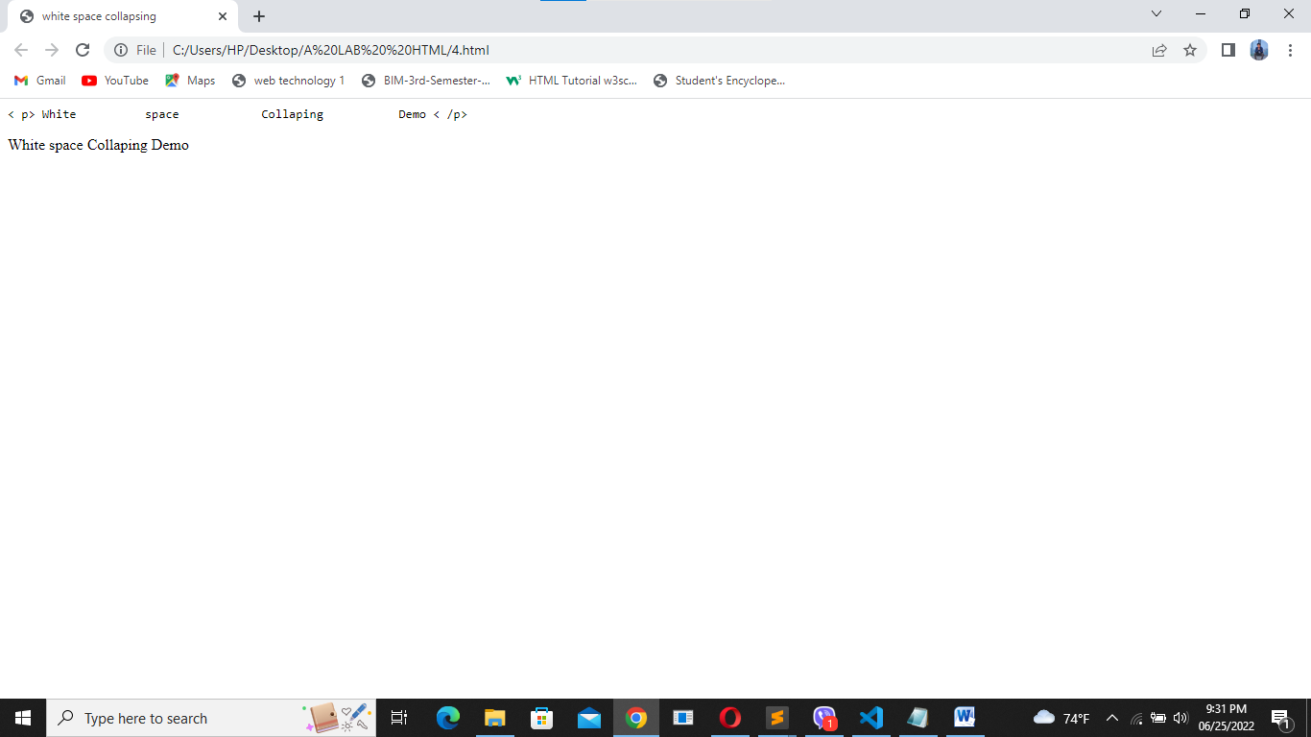

1. Create two paragraphs. Paragraph 1 containing the heading as Management Colleges in Nepal and Paragraph 2 containing the heading as Engineering Colleges in Nepal. Heading of Paragraph 2 must be smaller than the heading of Paragraph 2. Also show the use of b, i, sup, sub, small, strong, abbr, acronym, blockquote with cite attribute, cite, q tag inside the two paragraphs.

Code:

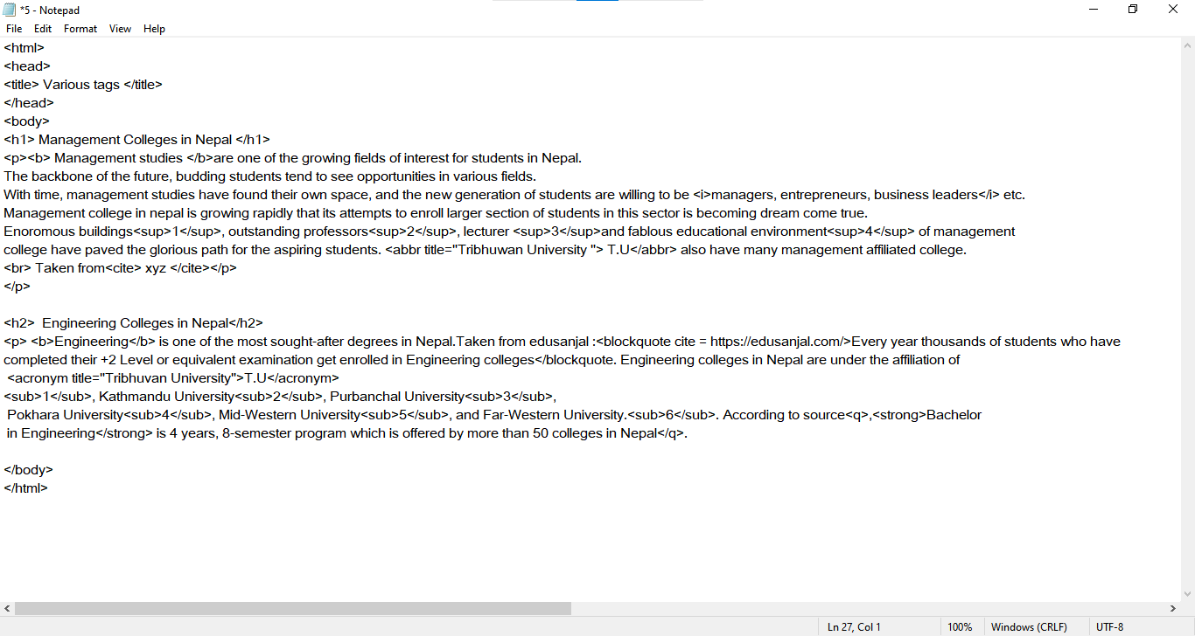

Output:

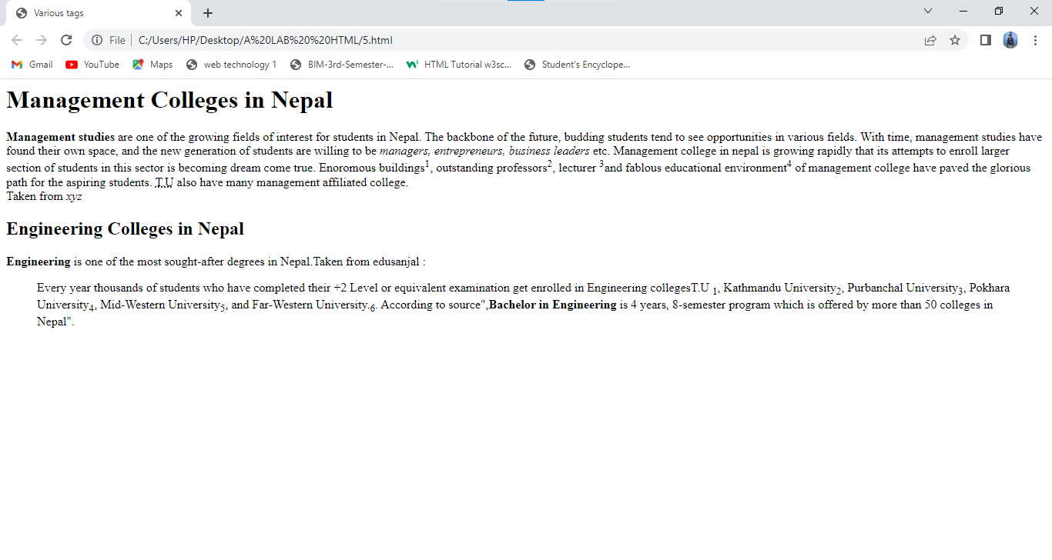

1. Write the HTML code to display the following output:

Hi,

My

Name

Is

John

Code:

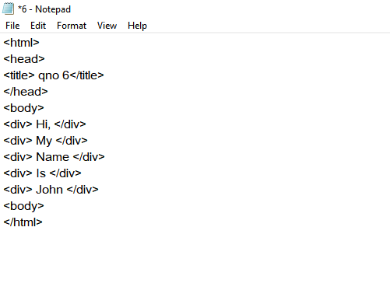

Output:

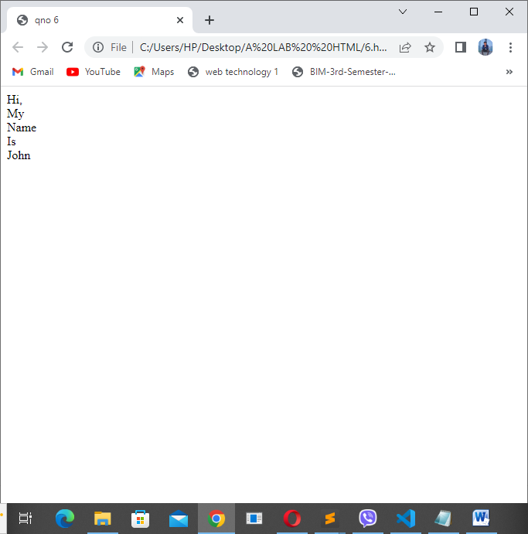

1. Write the HTML code to demonstrate
   1. code
   2. kbd
   3. var
   4. samp

Code:

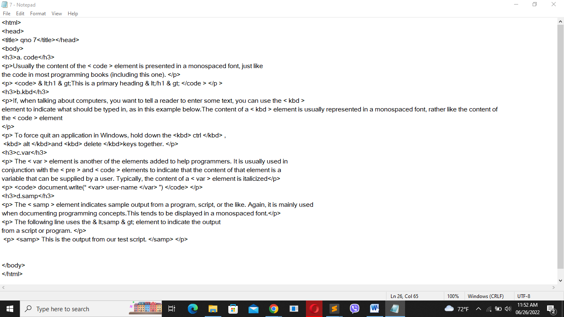

:

Output: 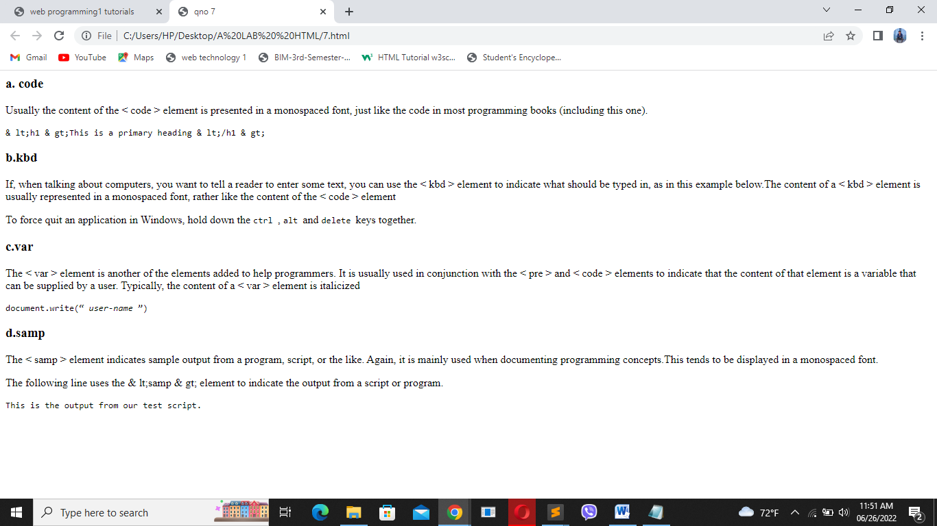

1. Write a HTML code to demonstrate the concept of :

a. Unordered list

b. ordered list

c. Nested unordered list

d. Nested ordered list

e. Definition list

Code:

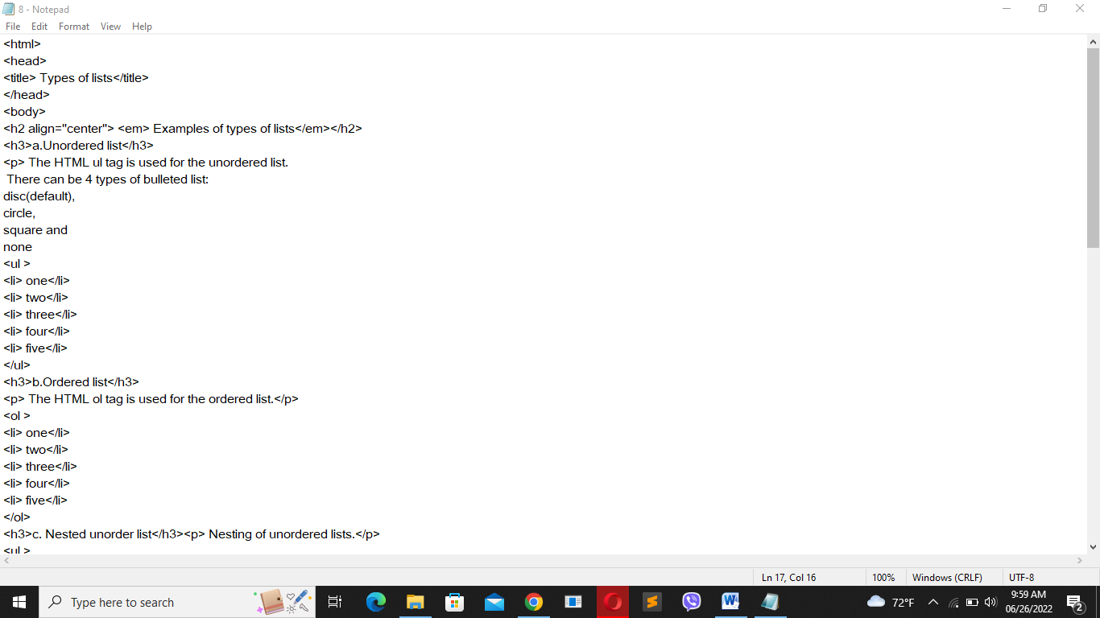

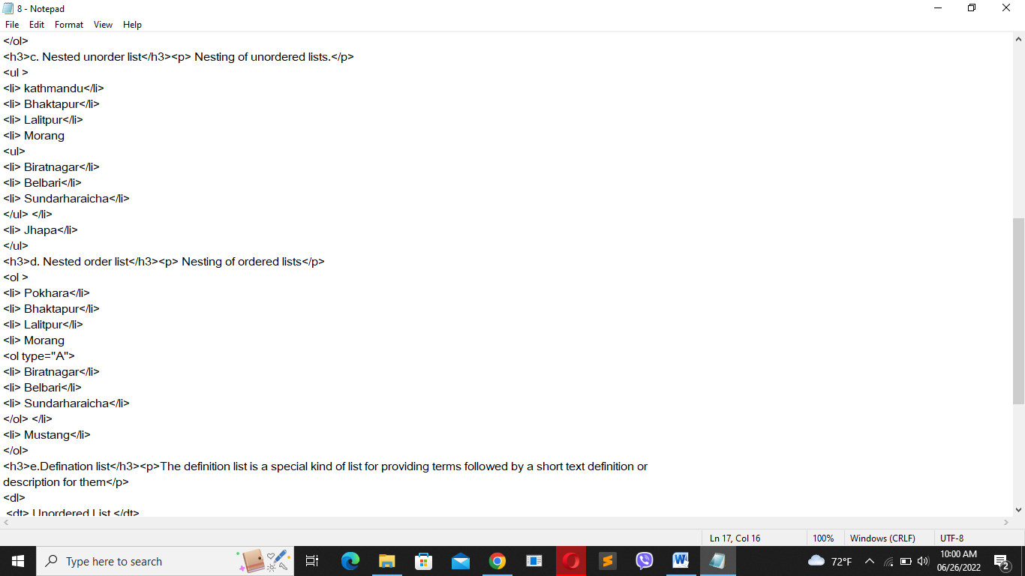

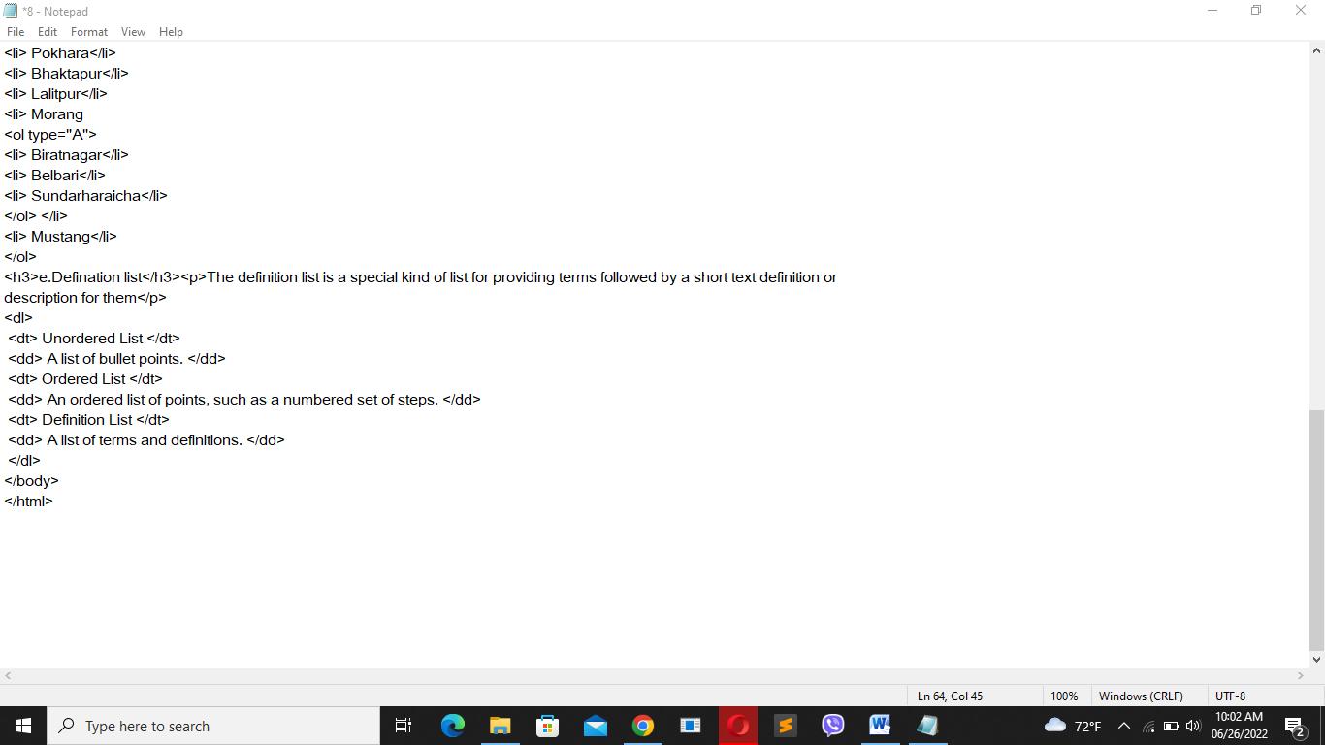

Output:

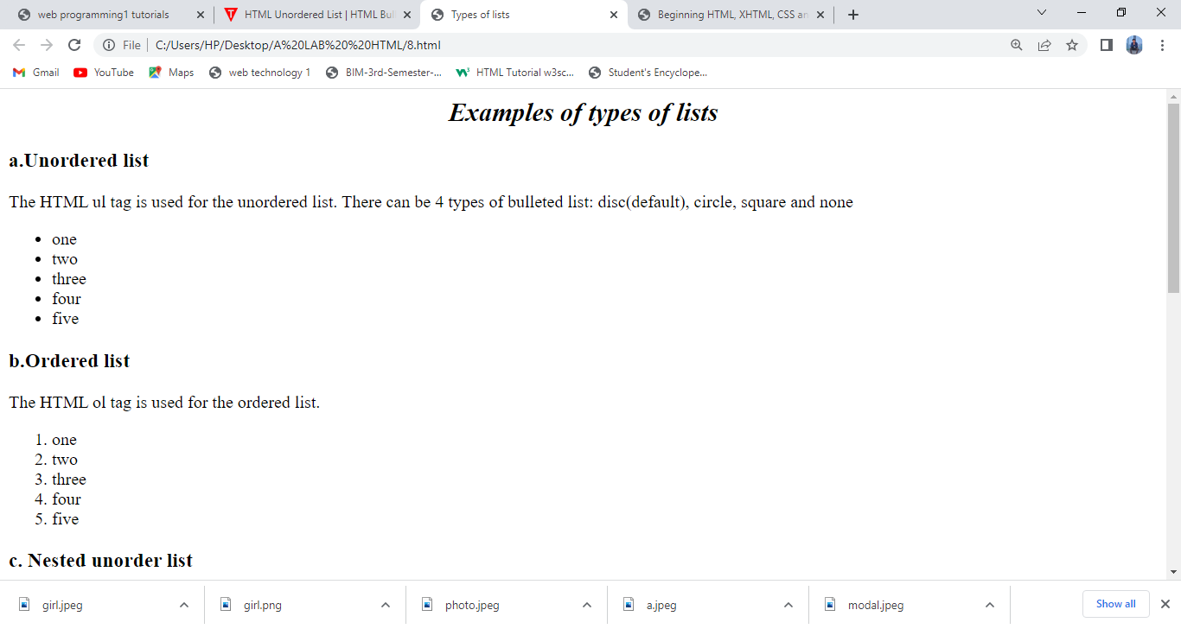

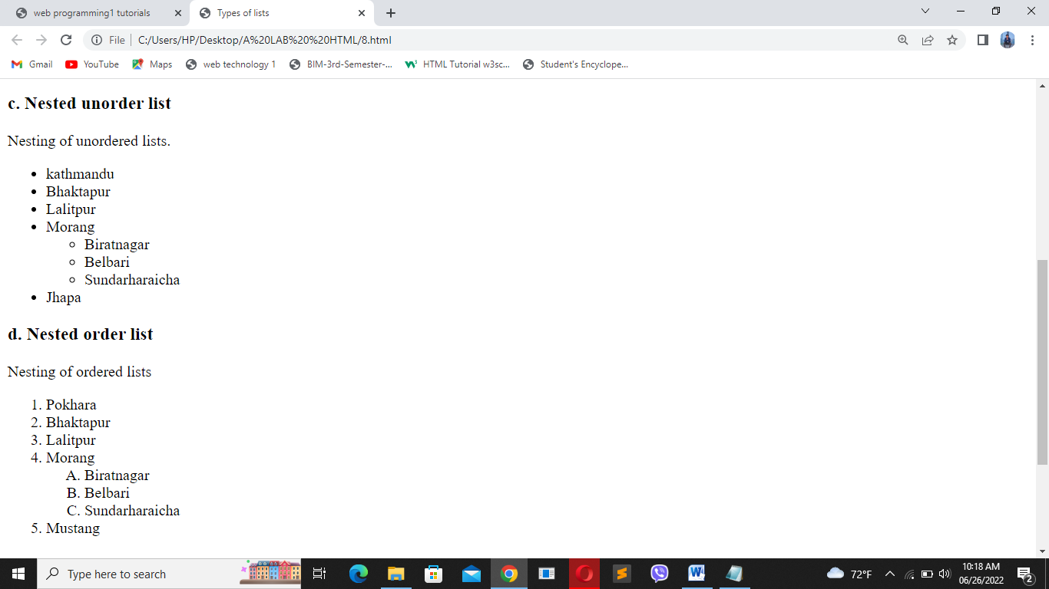

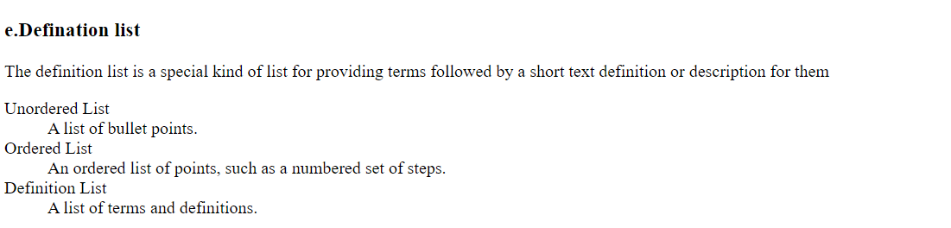

1. Write the HTML code to demonstrate image as list.

Code:

Output:

1. Write the HTML code to demonstrate the use of URL along with Absolute URL, Relative URL

Code:

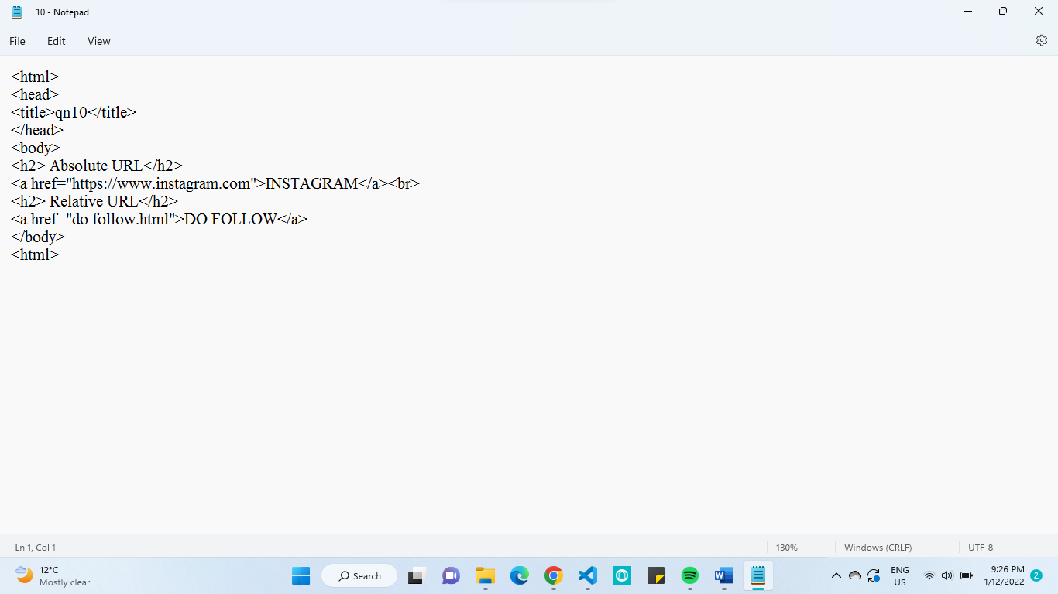

Output:

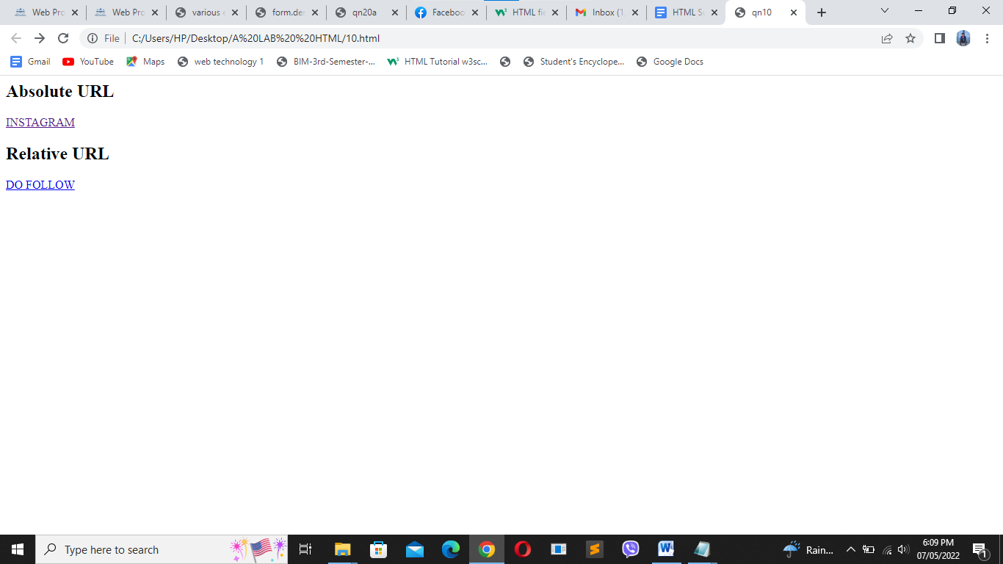

1. How can you create link in HTML? Show a proper section of code

Code: 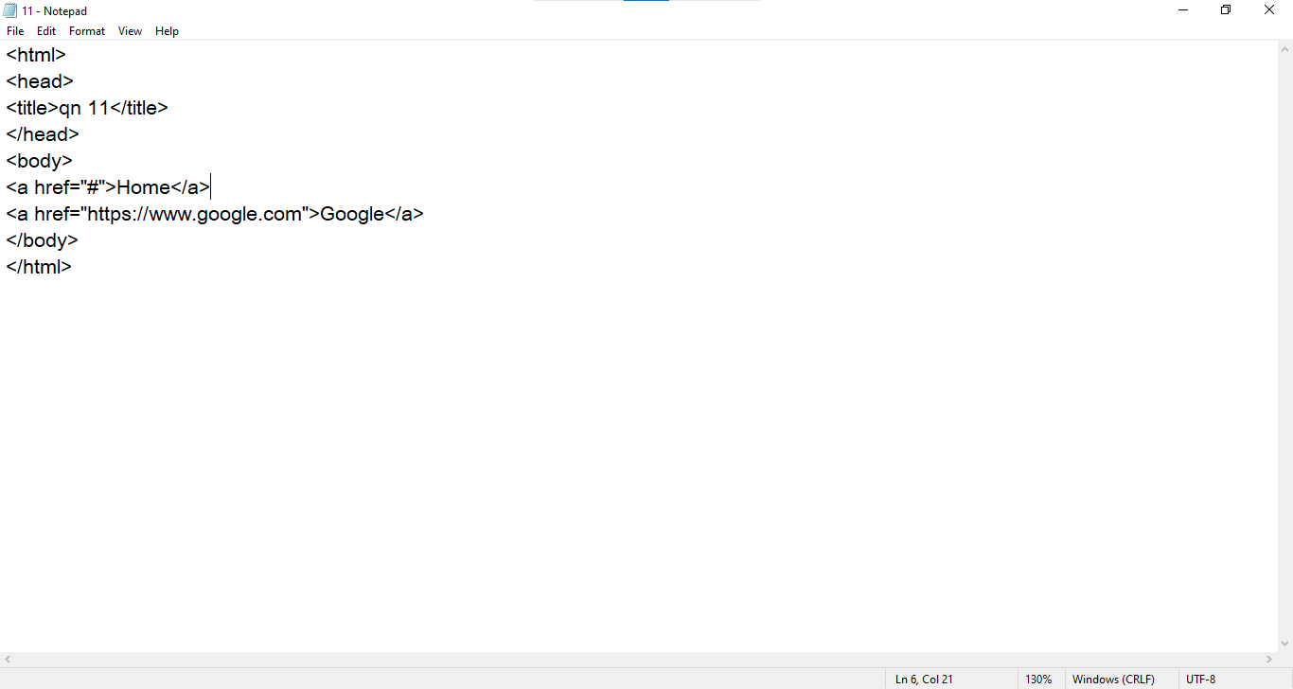

Output:

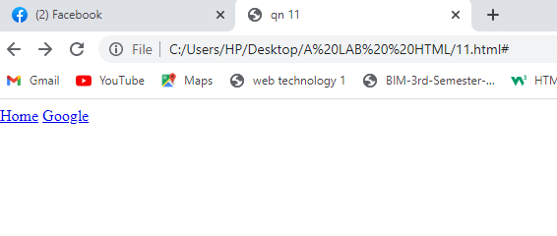

1. Write the HTML code to generate the following output with the use of anchor tag

Home About Gallery The home is in parent directory, about is in sub directory of home and Gallery is in root directory. Write the code for each and every tab

Code for Home:

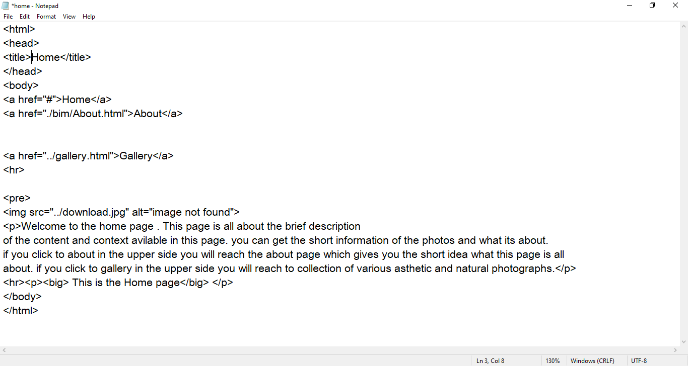

Code for About:

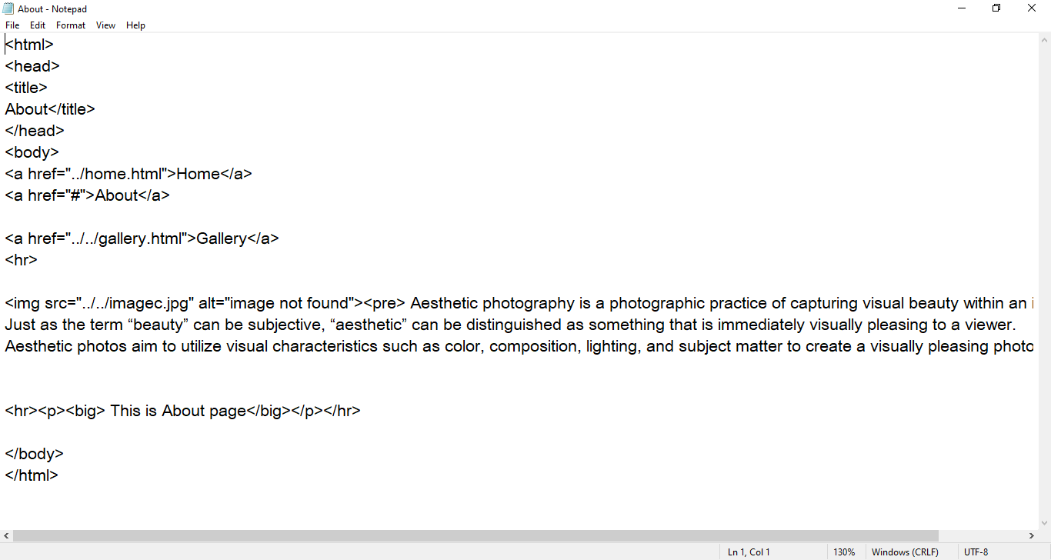

Code for Gallery:

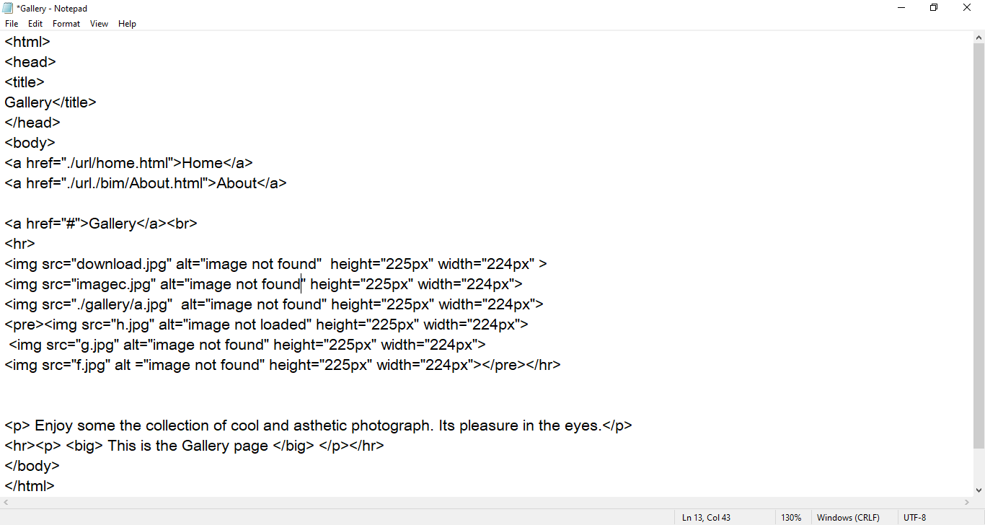

Output:

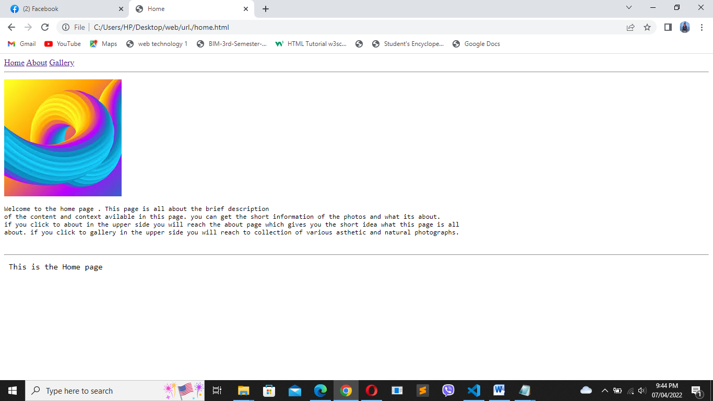

1. Create a web page that demonstrate the use of destination anchor using name and id attributes

Code:

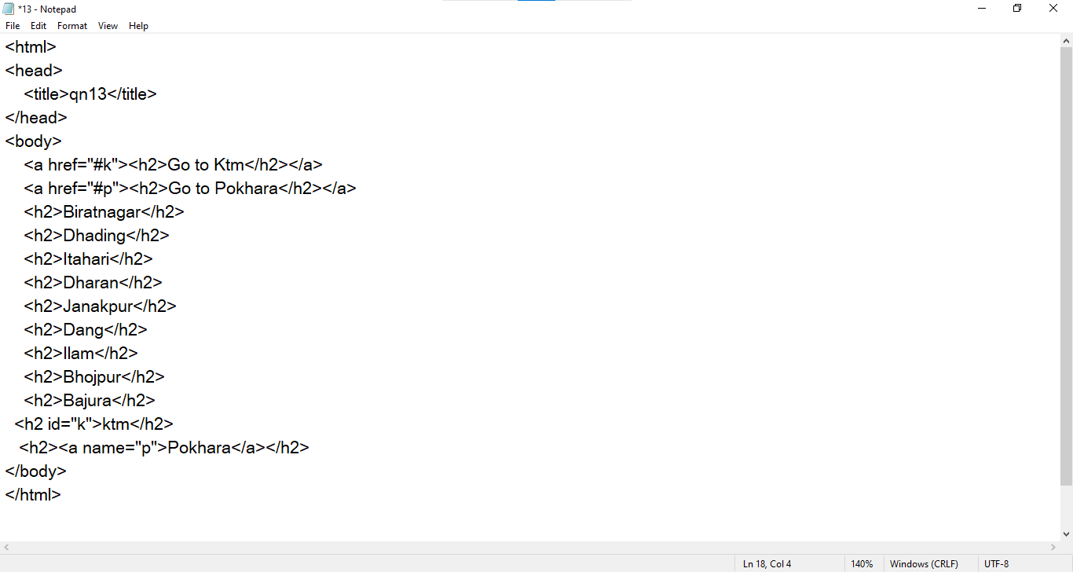

Output:

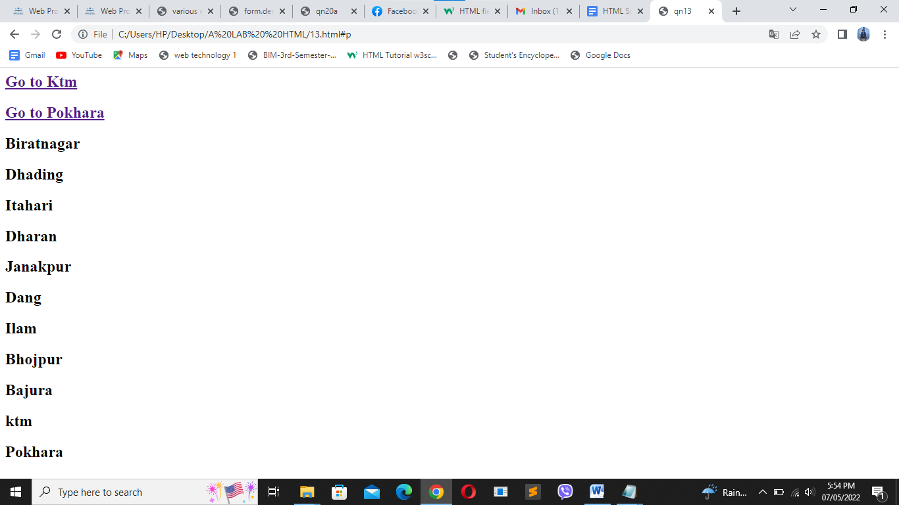

1. Add image using img tag

Code: 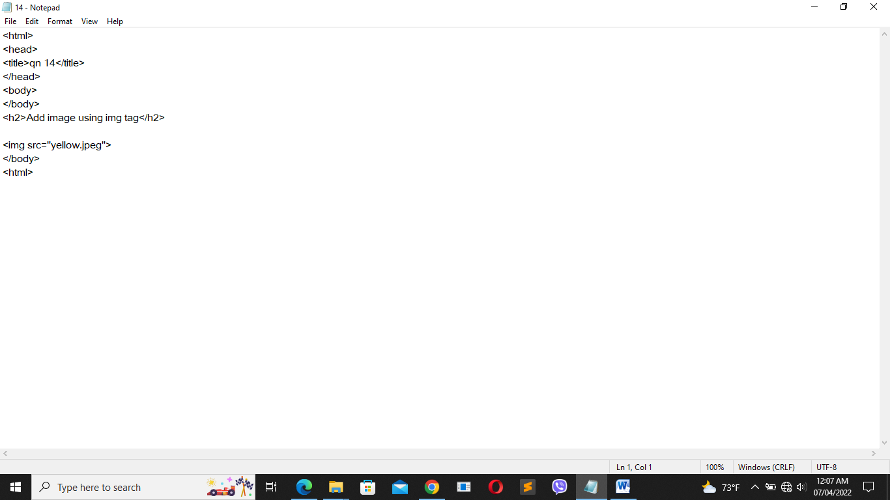

Output:

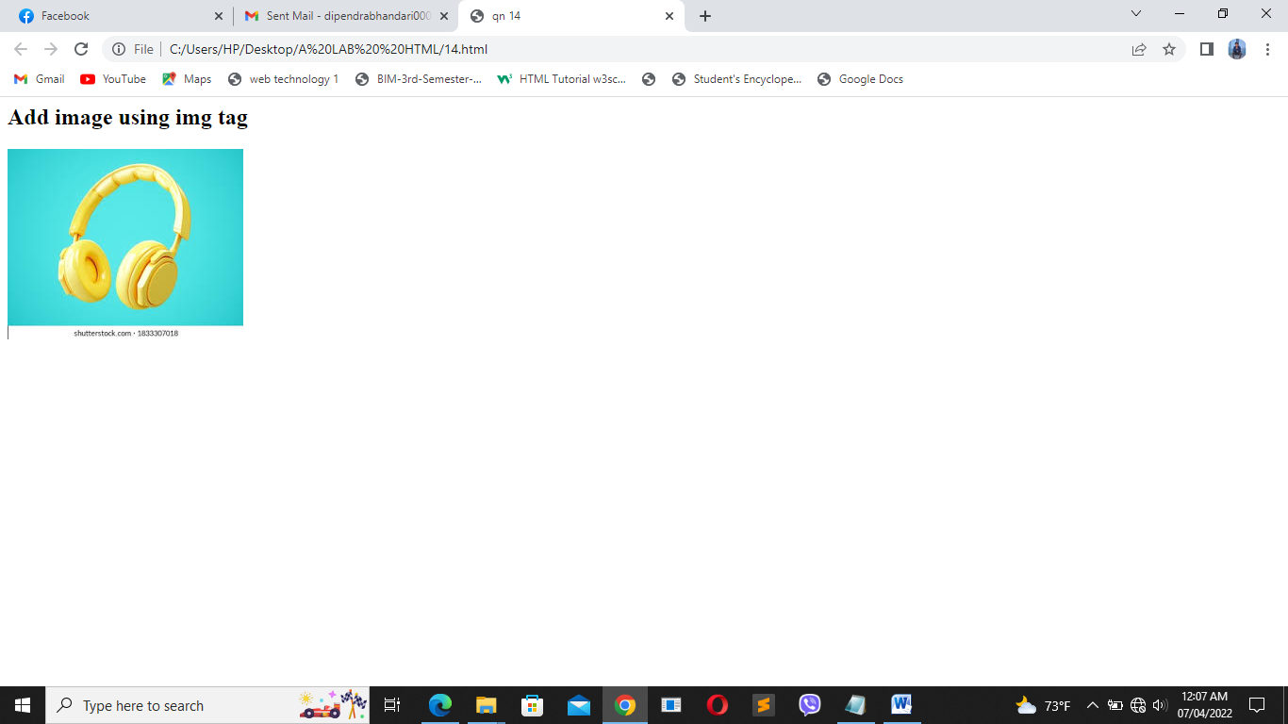

1. Create an image gallery of 9 images with 3 images in a row each having 200 width and height 250

Code:

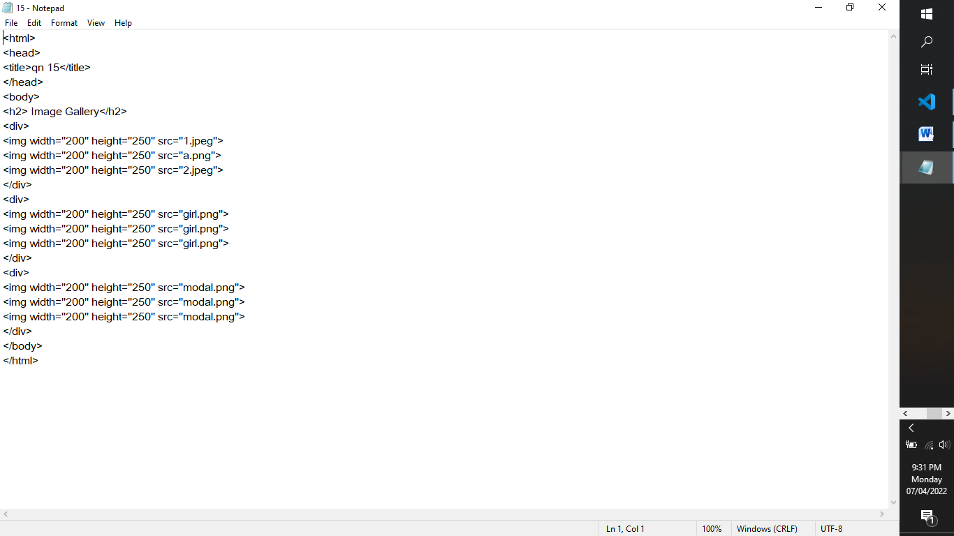

Output:

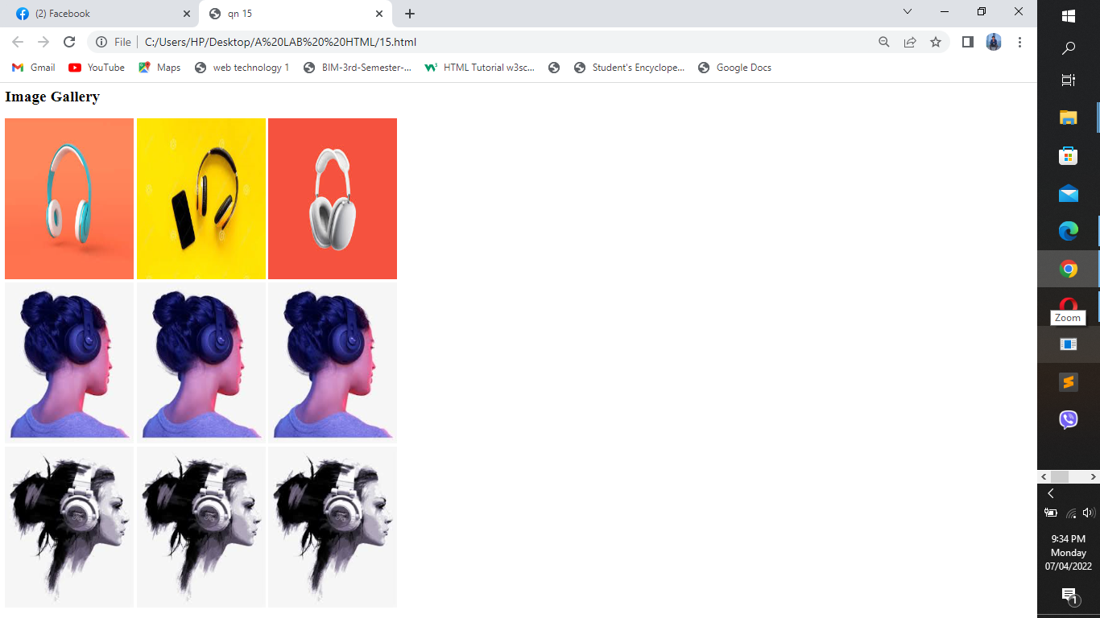

1. Write a HTML code to map image as Client side and Server Side

Code:

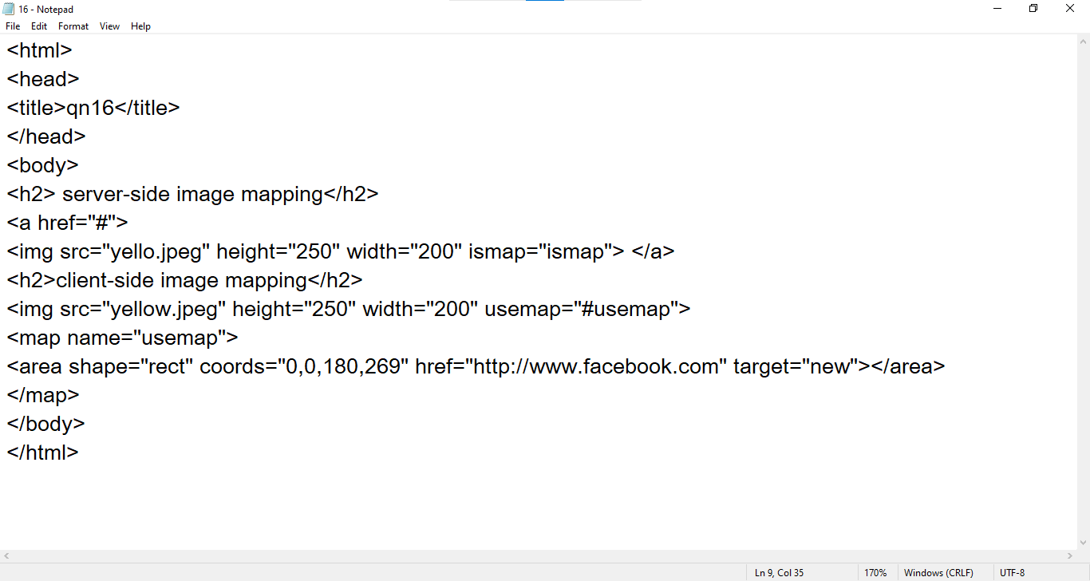

Output:

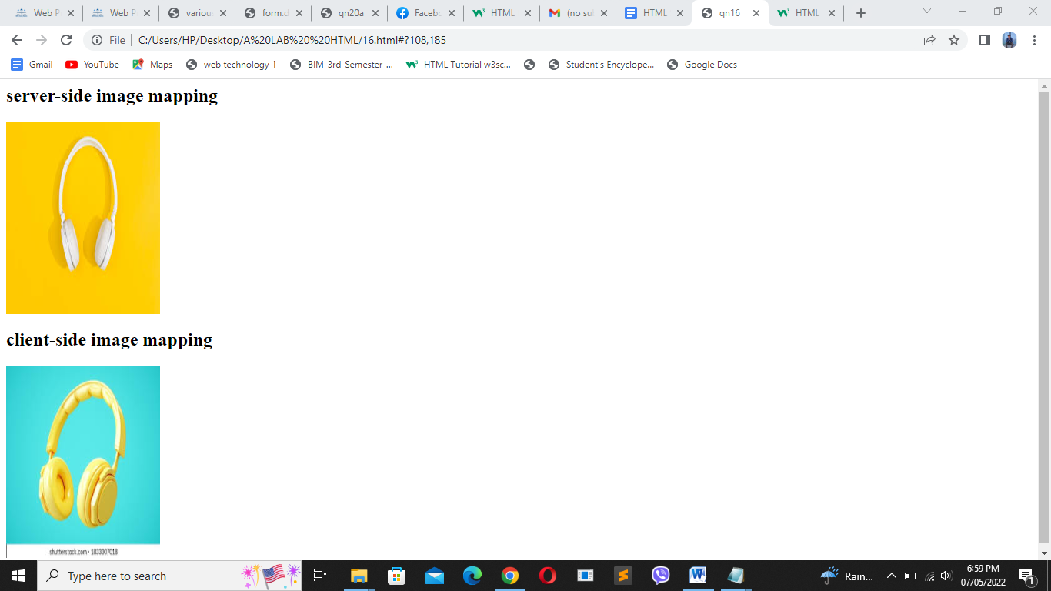

1. Write a HTML code to demonstrate how audio, video can be added to the web pages along with all the attributes

Code:

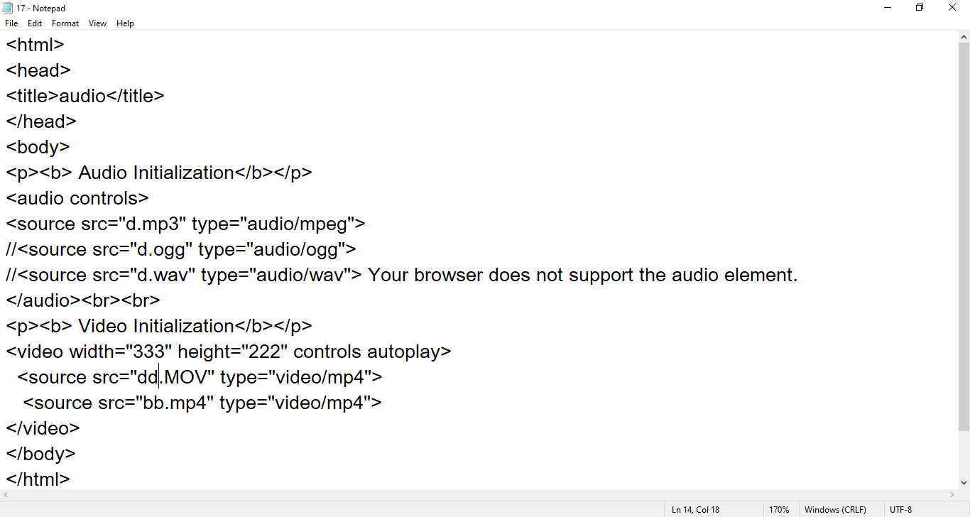

Output:

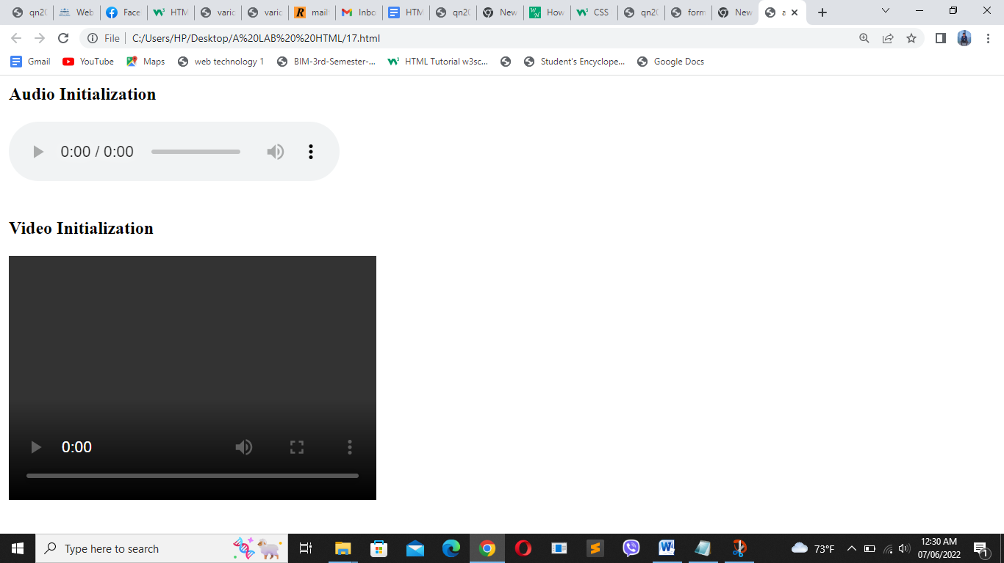

1. Write the HTML code to print the following output:

Code:

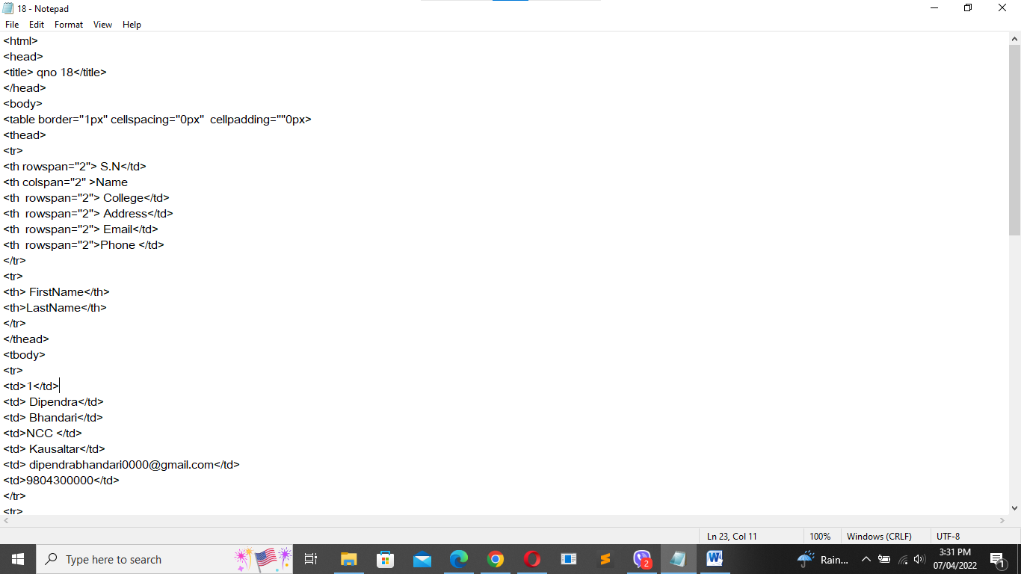

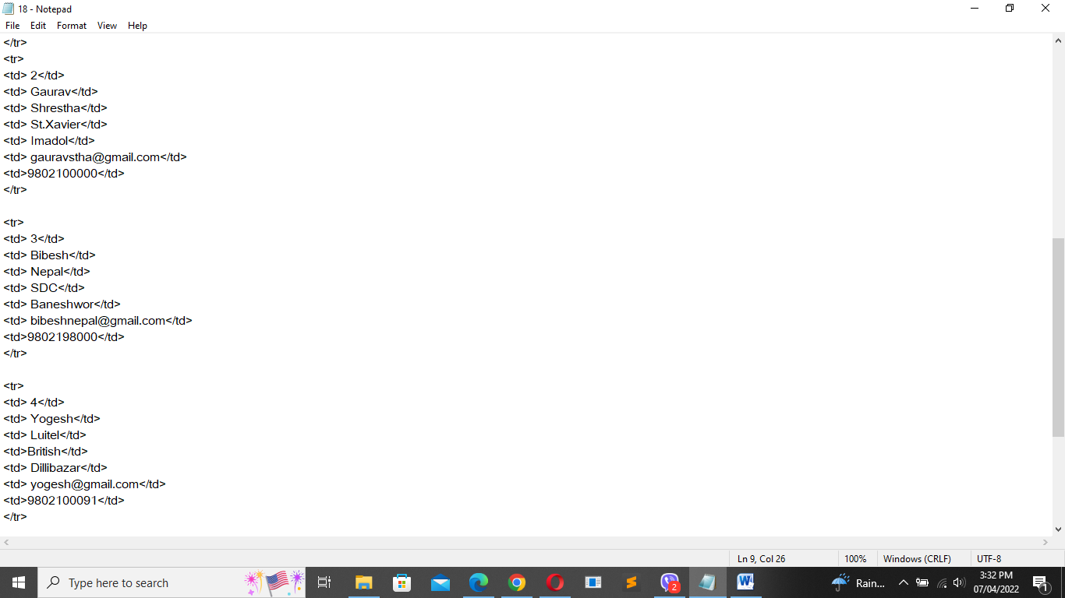

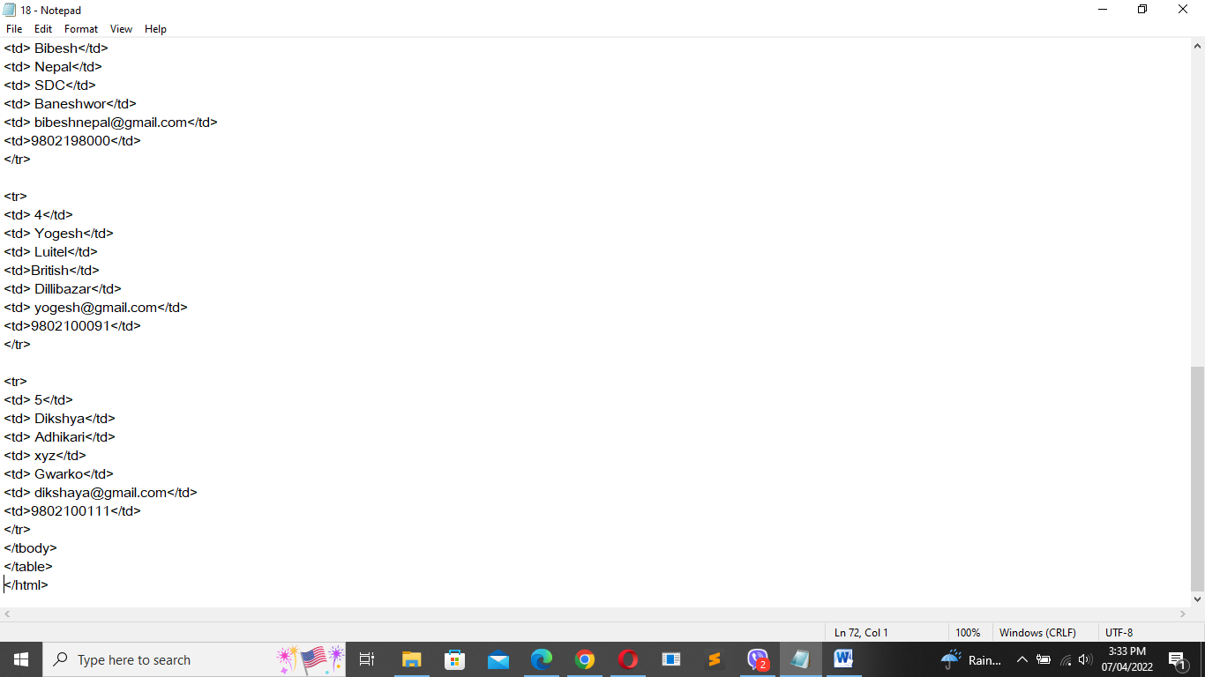

Output:

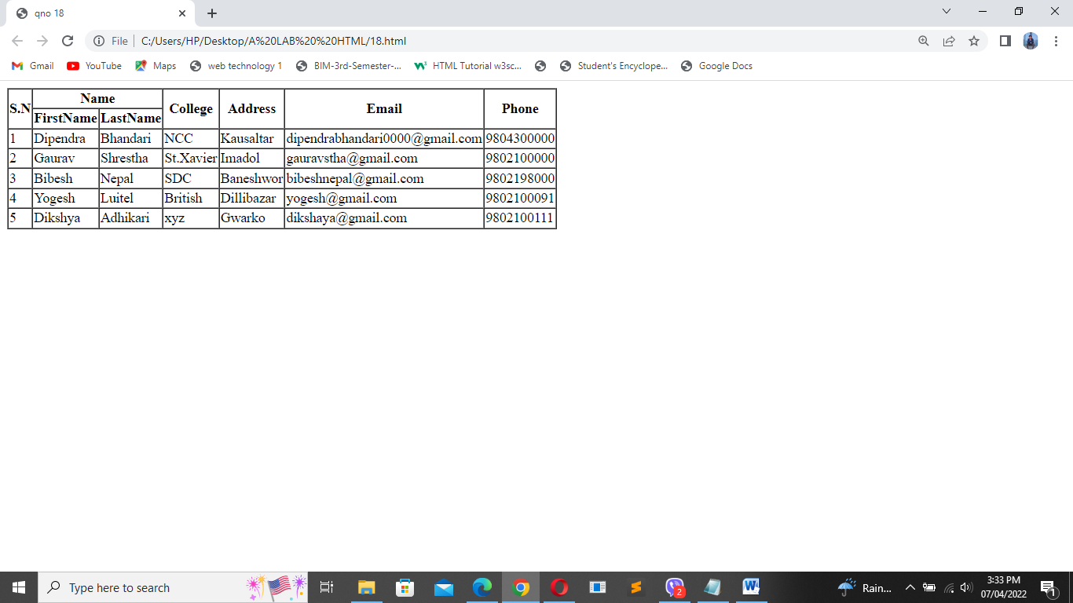

1. Write XHTML code to demonstrate the use of Nested table with rowspan and colspan attribute

Code:

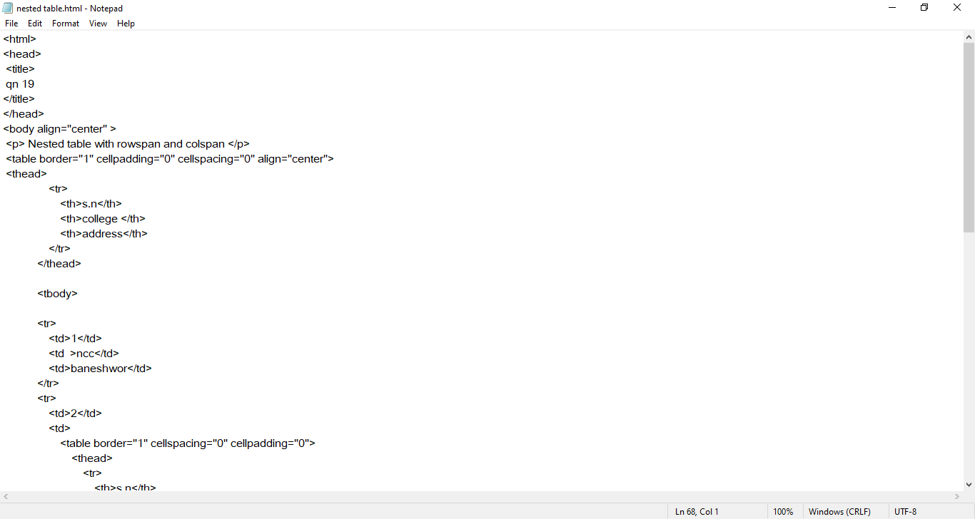

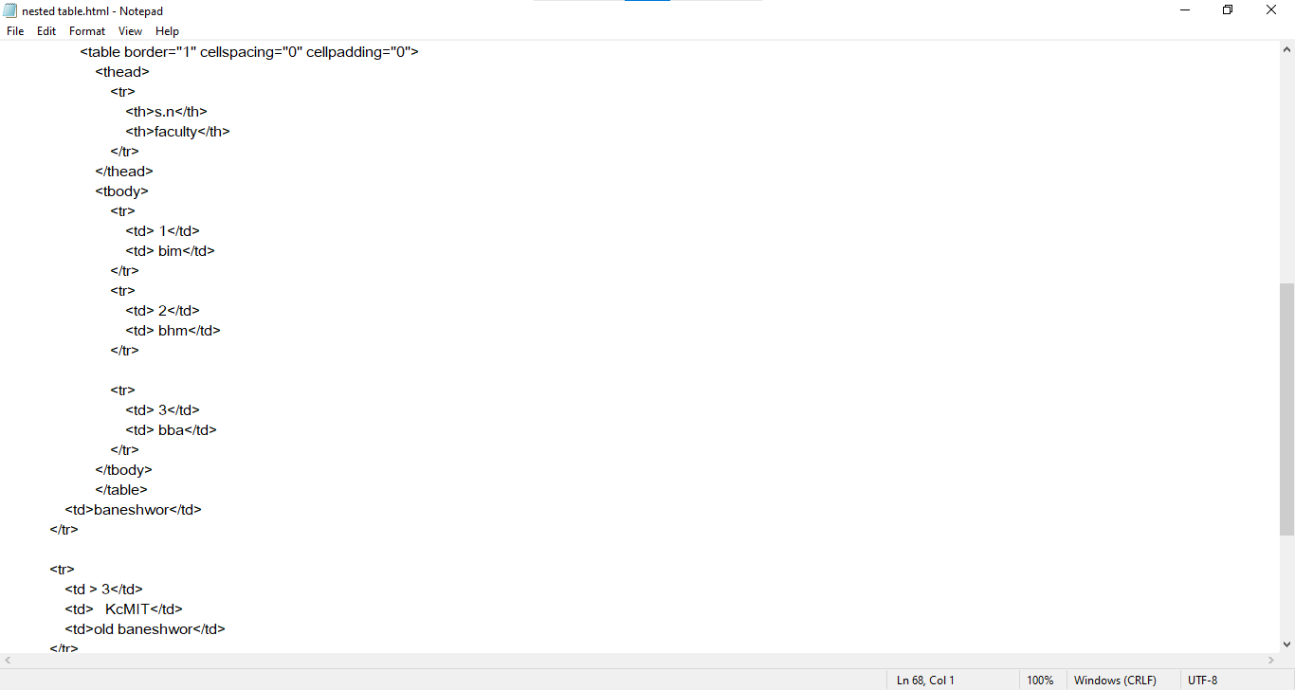

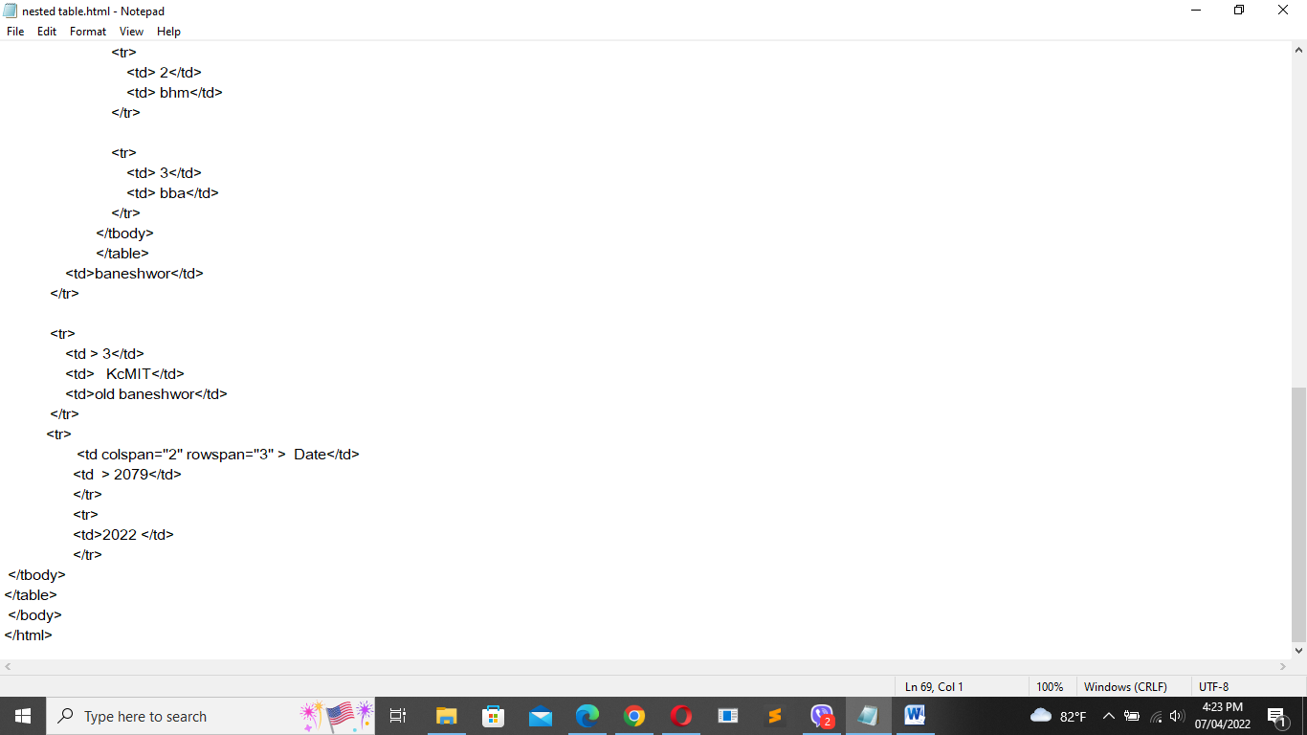

Output:

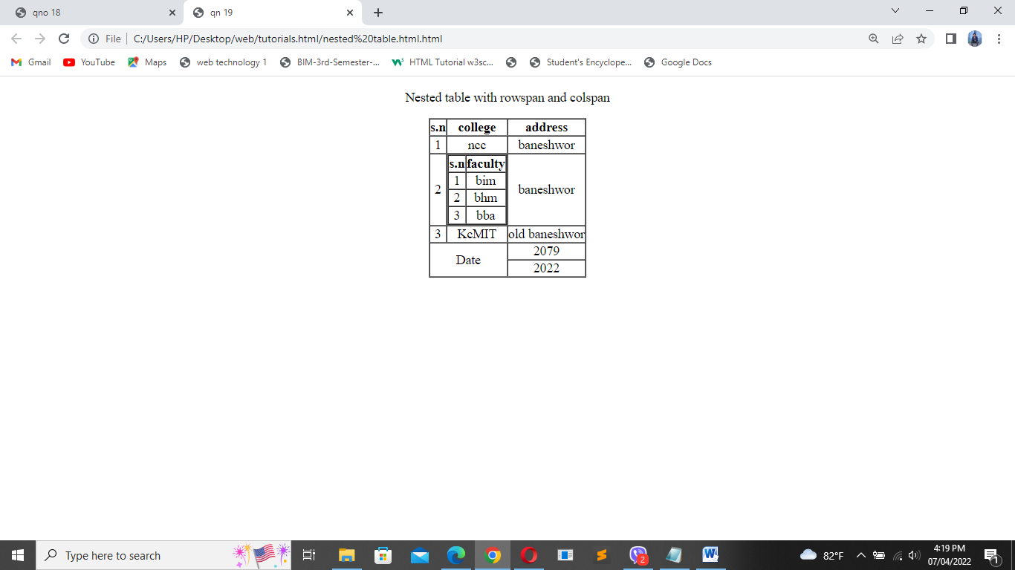

1. Write the code and provide the output of form from previous board questions.
2. Year 2015

Code:

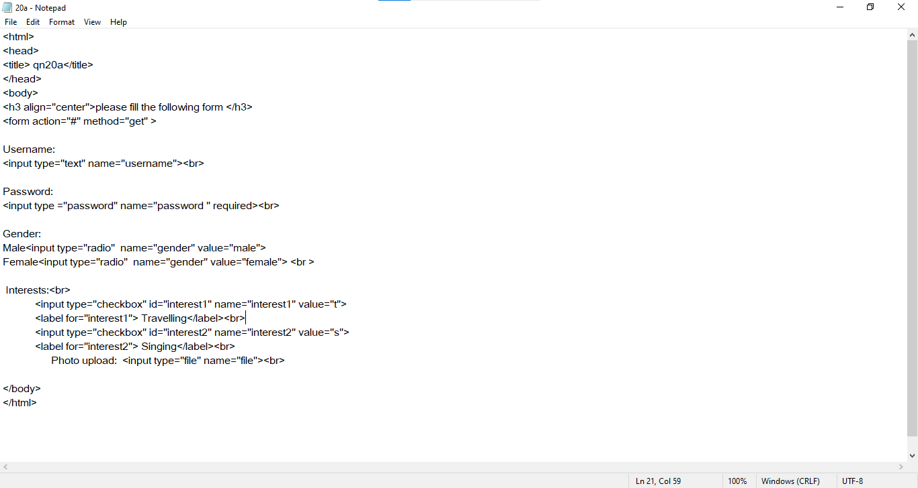

Output:

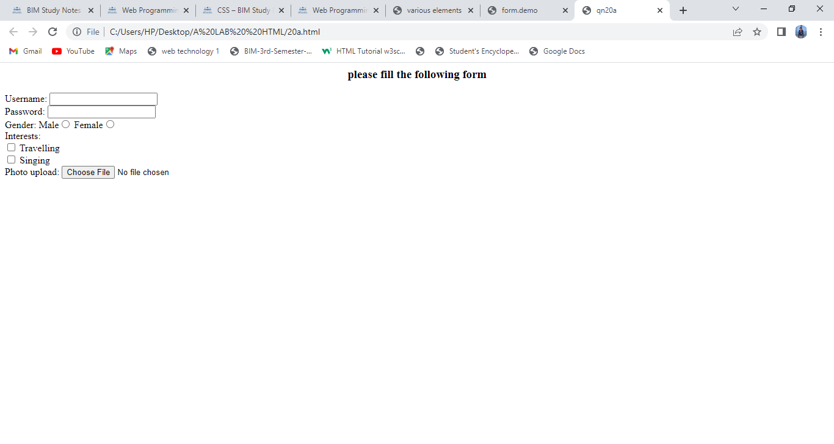

1. Year 2016

Code: 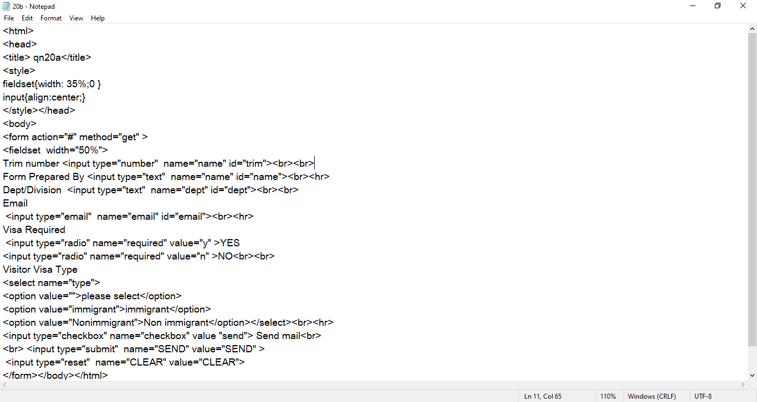

`

Output:

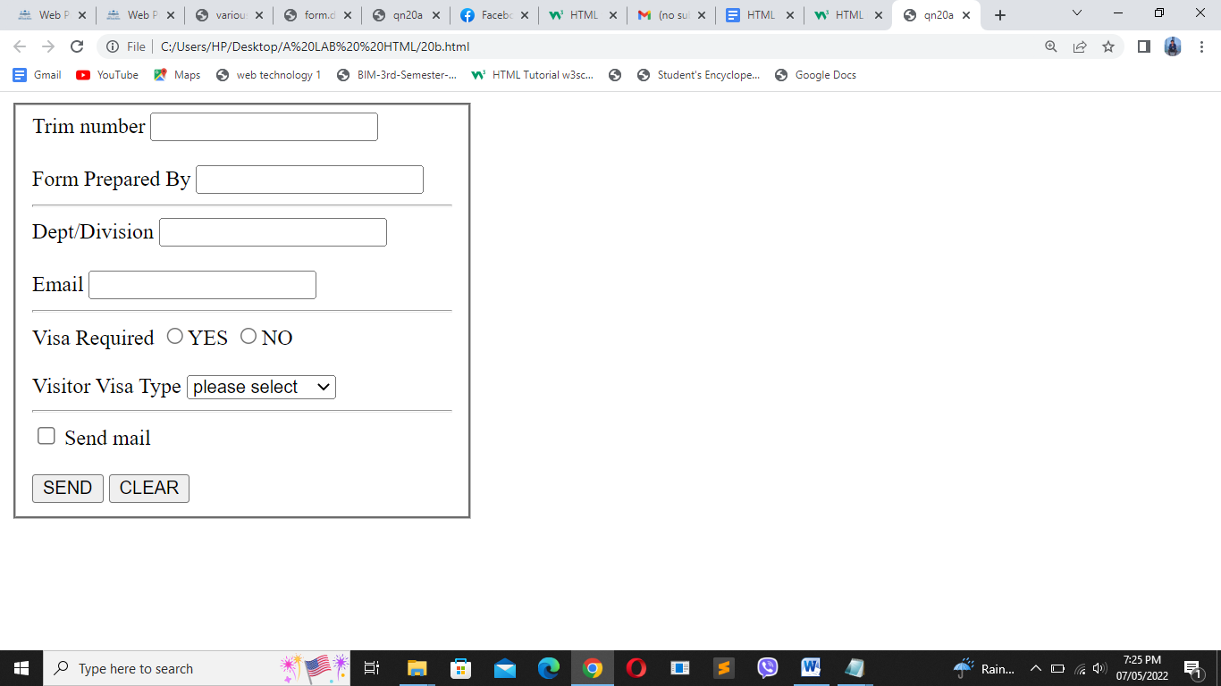

1. Year 2017

Code:

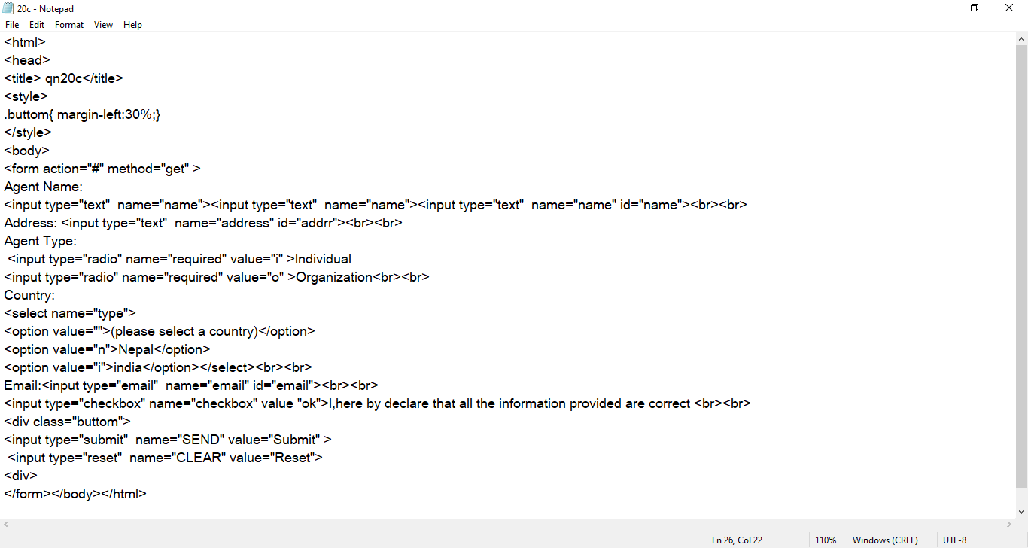

Output:

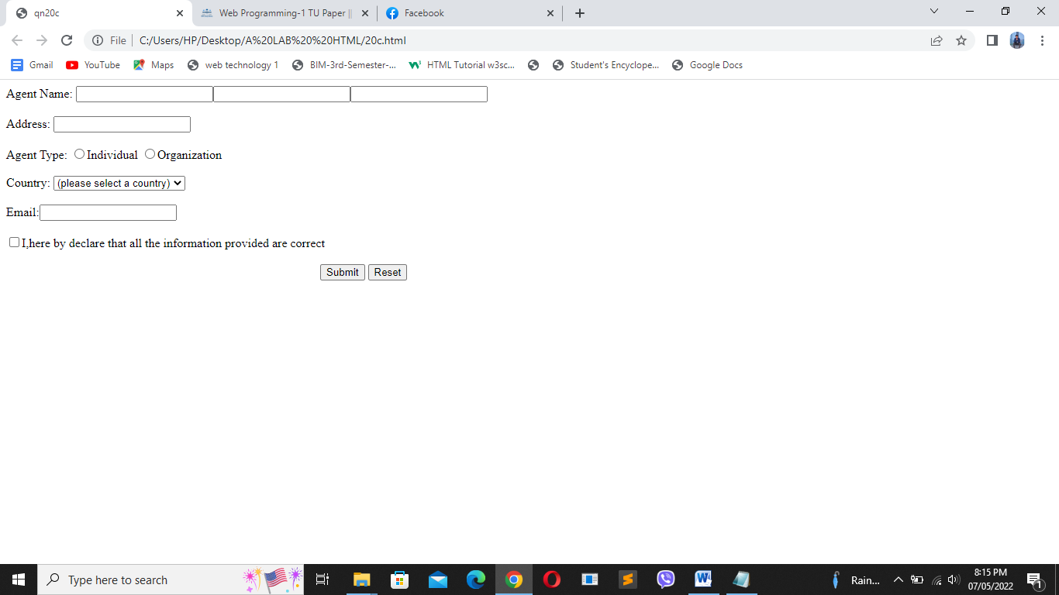

1. Year 2018

Code: <!DOCTYPE html PUBLIC "-//W3C//DTD XHTML 1.1//EN"

"http://www.w3.org/TR/xhtml11/DTD/xhtml11.dtd">

<html xmlns="http://www.w3.org/1999/xhtml">

<head>

<title>qn20d</title>

</head>

<body> <form method="get" action="#" align="center">

<fieldset >

<legend align="left">

Contact Us

</legend>

<br/>

<label for="name">Name:</label>

<input type="text" name="name" id="name" tabindex="5"><br/>

<label for="password">Password:</label>

<input type="password" id="password" required tabindex="6"><br/>

Email:

<input type="email" name="email" tabindex="4"><br/>

Phone No:

<input type="number" name="number" tabindex="3"><br/>

Date:

<input type="date" name="date" tabindex="1"><br/>

Gender:

<input type="radio" name="gender" value="male" >male

<input type="radio" name="gender" value="female" >female

<br/>

Vehicles:<br/>

<input type="checkbox" id="vehicle1" name="vehicle1" value="Bike">

<label for="vehicle1"> I have a bike</label><br/>

<input type="checkbox" id="vehicle2" name="vehicle2" value="Car">

<label for="vehicle2"> I have a car</label><br/>

<input type="checkbox" id="vehicle3" name="vehicle3" value="Boat">

<label for="vehicle3"> I have a boat</label><br/>

<br/>

Location:

<select name="location" tabindex="2">

<option value="">please select</option>

<option value="pokhara">pokhara</option>

<option value="ktm" >kathmandu</option>

<option value="brt">biratnagar</option>

<option value="lx">laxmimarga</option>

</select>

<br/>

Comments:

.<textarea name="textarea">Write down your comments </textarea><br/><br/><br/>

select file:

<input type="file" name="file"><br/>

<input type="checkbox" name="checkbox" value="ok" required>I accepts all the terms and condition<br/><br/><br/>

<input type="submit" name="submit">

<input type="reset" name="delete"><br/>

</form>

</body>

</html>

Output:

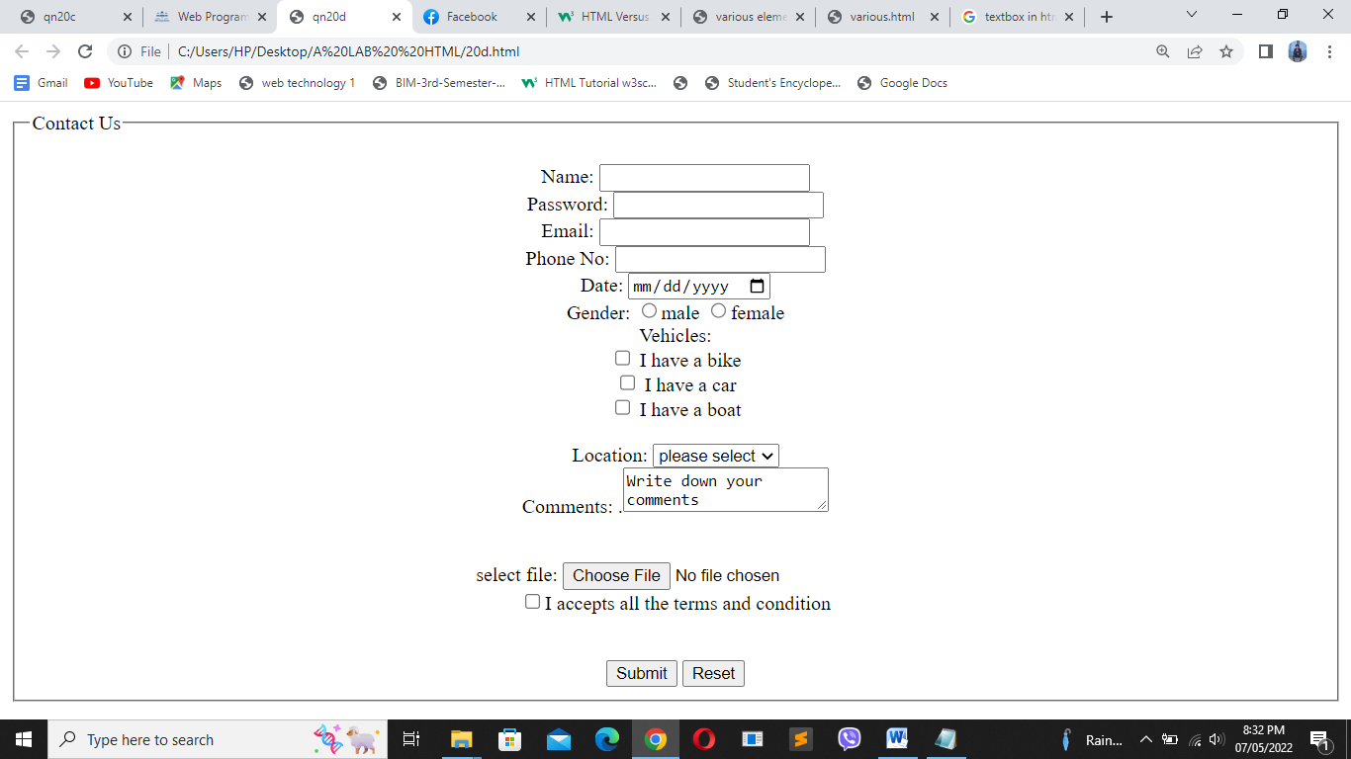

1. Year 2020(make up)

Code:

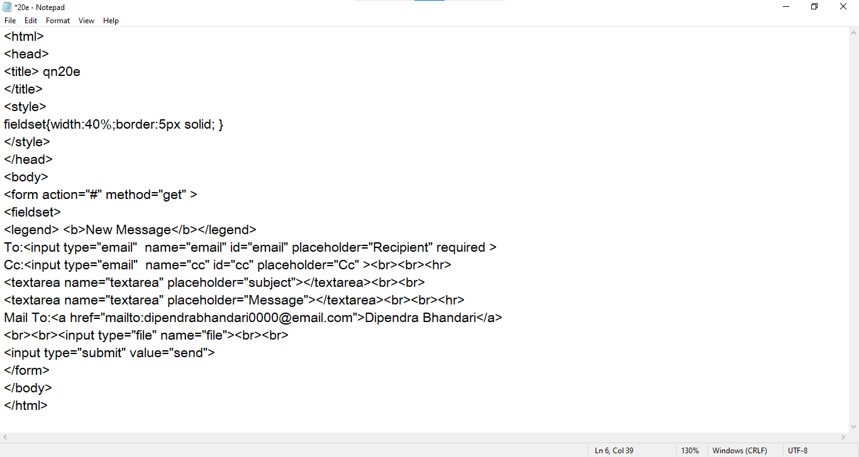

Output:

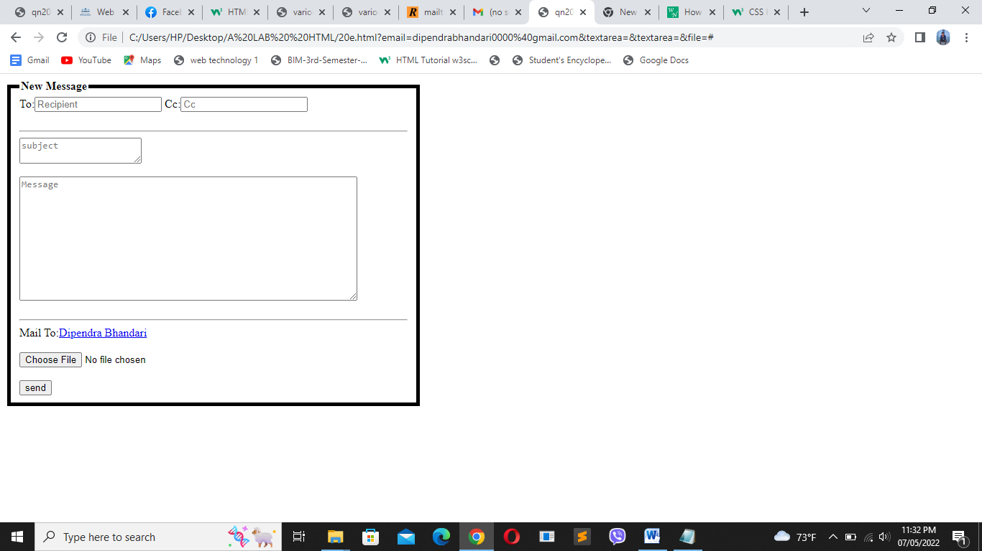

1. 2021(make up)

Code:

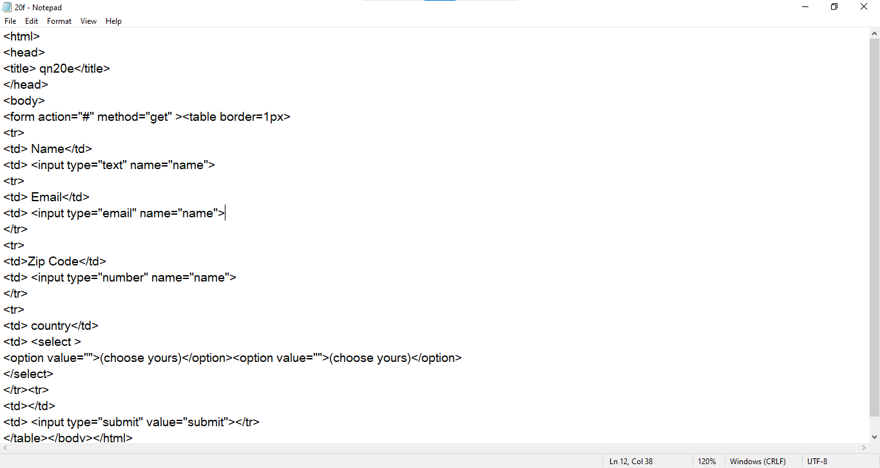

Output:

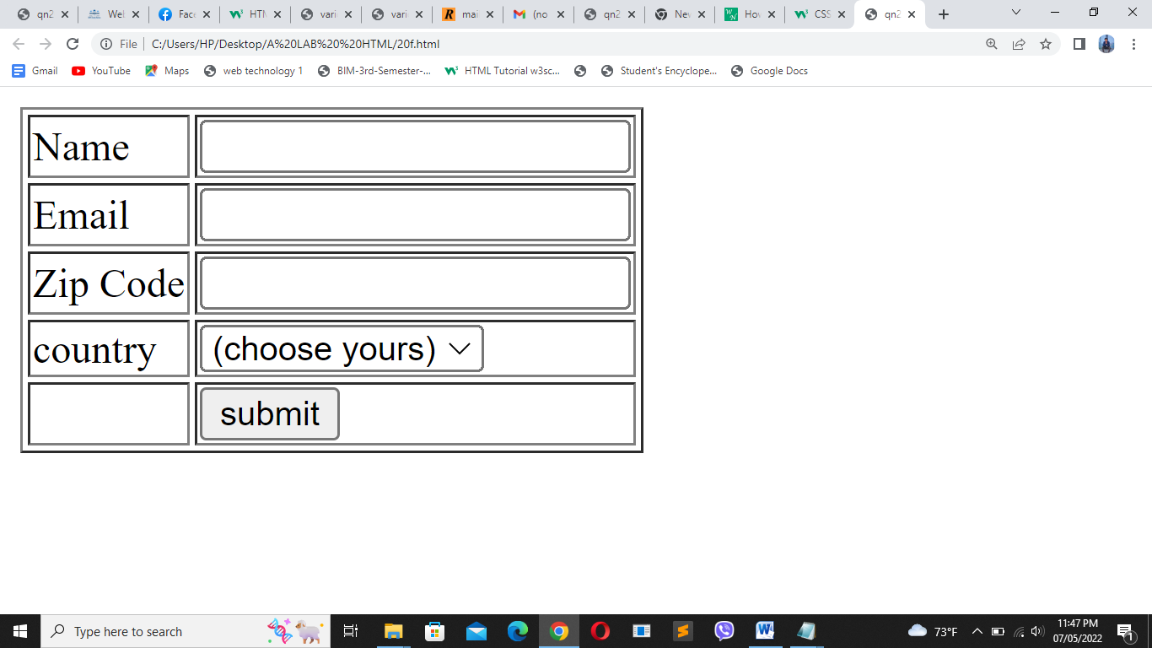

1. Form_demo

Code:

<html>

<head>

<title> form.demo</title>

</head>

<body>

<h3 align="center"><em>Fill the following form<em> </h3>

<form action="#" method="get" >

<table>

<tr>

<td>Name:</td>

<td><input type="text" name="name"></td></tr>

<tr>

<td>Age:</td>

<td><input type="number" name="age"></td>

</tr>

<tr>

<td>username:</td>

<td><input type="text" name="username"></td></tr>

<tr>

<td>password:</td>

<td><input type ="password" name="password " required></td>

</tr><tr>

<td>Gender:</td>

<td>Male<input type="radio" name="gender" value="male">

Female<input type="radio" name="gender" value="female"></td> </tr >

<tr>

<td>Location:</td>

<td><select name="location" value="location">

<option value="">please select</option>

<option value="pokhara">pokhara</option>

<option value="ktm" >kathmandu</option>

<option value="brt">biratnagar</option>

<option value="lx">laxmimarga</option>

</select></td>

</tr><tr>

<td>Date:</td>

<td><input type="date" name="date"></td></tr>

<tr>

<td>Comment:</td>

<td><textarea name="name"

row="20" cols="50" placeholder="write down your comment here">

</textarea>

</td></tr>

<tr><td>

<input type="checkbox" name="checkbox" value="ok" required>I accepts all the terms and condition</td>

<td><input type ="submit" name="ok " required>

<input type ="reset" name="clear" required></td>

</td></tr>

<br>

</table></form>

</body>

</html>

Output:

